LABORATORY EXERCISE 4

EXPERT SYSTEM WITH BACKWARD CHAINING

Learning Objectives
By the end of this laboratory exercise, students should be able to:
- Differentiate between the forward chaining and backward chaining inference strategies.
- Implement a simple backward-chaining inference mechanism for goal-driven reasoning.
- Design a knowledge base for a specific, non-trivial domain (animal classification).
- Evaluate the strengths and weaknesses of a rule-based expert system and propose enhancements for real-world use.

Prerequisite student experiences and knowledge
Before starting this exercise, students should have:
- Completed Laboratory Exercise 3 (Rule-Based Inference) or have equivalent knowledge of forward chaining.
- Proficiency in Python programming, including recursion and object-oriented concepts.
- Understanding of logic and set theory (AND, OR, implications).
Background
An Expert System is a key application of symbolic AI designed to emulate the decision-making ability of a human expert. It consists of two main components:
- A knowledge base, containing domain-specific facts and heuristic rules.
- An inference engine, which reasons over the knowledge base.
While forward chaining is data-driven, backward chaining is goal-driven. It begins with a hypothesis and works backward, checking the rules to see if the known facts can support that goal. This is highly efficient for diagnostic and classification problems with a large number of possible conclusions. Still, the user is only interested in verifying a specific one, such as "What animal is this?" or "What is the system's fault?".

Materials/Resources
- A PC with a Python 3.x interpreter installed.
- A code editor (e.g., VS Code, PyCharm, or IDLE).
- Internet access for research (optional).
- Version Control: Git and GitHub.

Laboratory Activity
Instruction
- You will extend the rule-based system from the previous lab by implementing a backward-chaining inference engine.
- The system will use the same knowledge base structure:
  - A set of facts and a list of IF-THEN rules.
- The `infer_backward(goal, facts, rules)` function should determine if a given `goal` can be proven true. It should:
  - Return `True` immediately if the `goal` is in the `facts` set.
  - Otherwise, find all rules whose consequent (THEN part) matches the `goal`.
  - For each matching rule, recursively check if *all* conditions in its antecedent (IF part) can be proven true (`infer_backward` for each condition).
  - If any rule's entire antecedent can be proven, the goal is proven; return `True`.
  - If no rules can prove the goal, return `False`.
- The system should ask the user for a goal to prove (e.g., "cheetah") and then display the reasoning process and the conclusion.

Output / Results
- Document the implemented code.
- Screenshots of the console output for all questions
- A screenshot of the console output shows the recursive reasoning process.
- The link to the GitHub repository should be a 4-day commit before checking.
- Show your code modification and provide a screenshot of the new output proving the goal `tiger`.

Starter Code Skeleton
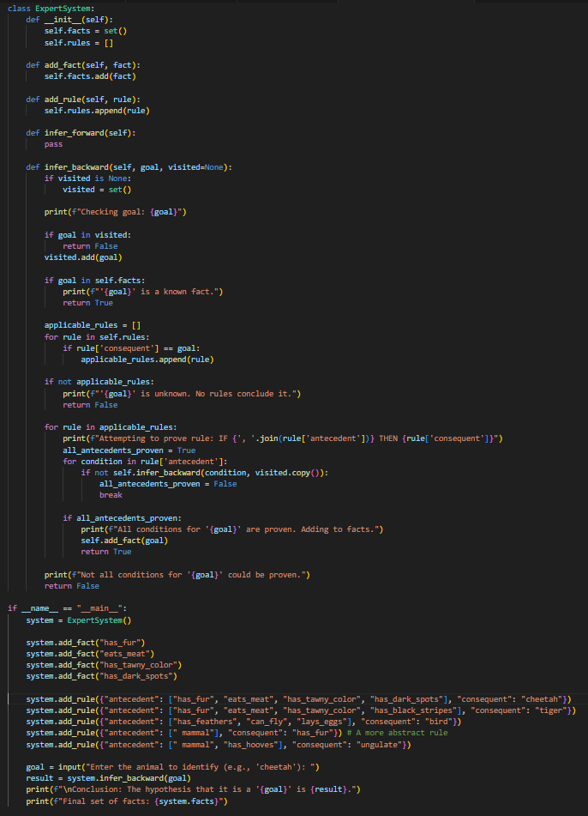
QUESTIONS:
- Run the provided code with the initial facts (`has_fur, eats_meat, has_tawny_color, has_dark_spots`) and the goal `cheetah`.
Explain in your own words the step-by-step process the backward chaining algorithm took to prove the goal.
  - Why is the output different from simply running a forward chainer?

How does backward chaining work?
- First of all it takes a data from the user and store it to a variable called “goal”. In the code example, the user has entered “cheetah” as the goal. So, since the goal is cheetah it will try to look for a rule that has a consequent “cheetah” using this code;
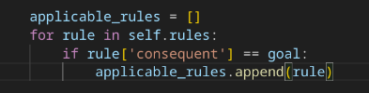
If the goal has no matching consequent in the rules the program will display “is unknown. No rules conclude it.” using this code;
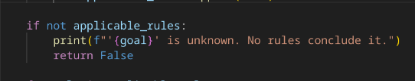
Since the goal “cheetah” matches to a consequent existed in a rule then it will check the antecedents of the rule from the known facts by visiting all the antecedents in the rule.
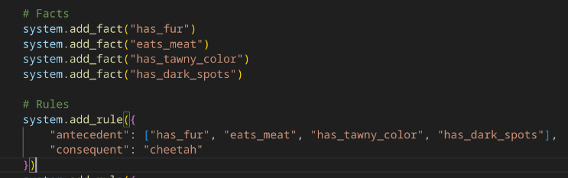
To keep track of visited antecedents we use use this code:
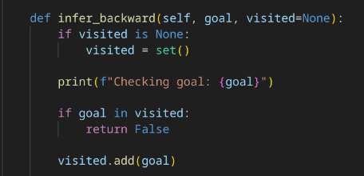

This for loop will attempt to prove the goal by checking the rules one by one if it matches to known facts
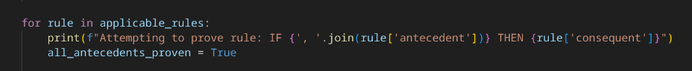
if none of antecendent matches to the known fact it will mark “all_antecedents_proven ”as False meaning no known facts matches the rules
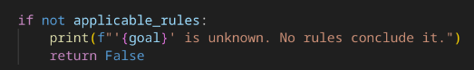
in our code, all of our known facts matches the rules marking “all_antecedents_proven” as True
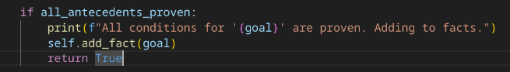
Lastly, after doing the backward chaining it will show a conclusion. In our code the conclusion was this;
because all of known facts matches the rules therefore it is proven that cheetah is True and then displaying all the facts that matches the rules.

  - Why is the output different from simply running a forward chainer?
- Forward chaining observes specific examples, data, or patterns and then generalizing from these specific instances to form a conclusion on the other hand backward chaining starts with general principles or assumptions and applying them to known facts and rules to prove that the goal is backed by known facts.

In simple terms forward-chaining implemented inductive reasoning while backward-chaining implements deductive reasoning.

- Now, set the goal to `tiger`.
  - What is the result?
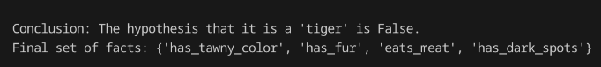
  - Explain why the system reached this conclusion.
- Is because there is an antecedent that didn’t match to existing facts. It results to a conclusion that tiger is False meaning the existing facts failed to find a proof that it is a tiger.

  - Modify the initial facts to identify a tiger correctly.
- To identify the tiger correctly I replaced the “has_dark_spots” in added_fact() into “has_black_stripes”.
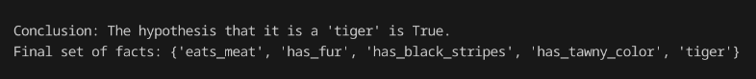

- The current knowledge base is simplistic.
  - Propose two new rules and facts to make the animal classification system more robust and hierarchical.
  - Write the Python code to add these rules.
  - Analyze a major limitation of this simple backward chaining system when dealing with a large, real-world knowledge base.
  - Consider factors like uncertainty, conflicting rules, or explanation capabilities. Propose one feature you would add to address this limitation.

I added two new rules and facts to the system and here’s the problem i encounter.
Uncertainty: Not all facts are 100% true/false (e.g., "can fly" isn’t always true for all birds).

Conflicting Rules: Two rules may give different conclusions (e.g., one rule says whale = fish, another says whale = mammal).

No Explanation Depth: The system only prints “True/False” but doesn’t explain why a rule failed.

So my proposal solution to these gaps was to replace True/False output as Percentage so that if one of antecedents has no match to known fact it will display the percentage instead of concluding that its hypotheses is False even though the other antecedent has a match to known facts.

How did i implement it to my code?
Every rule has antecedents right? divide 100% to number of antecedents in a rule and make it their value then use their value to count the percentage.

For example there are 4 antecedents in a rule, divide 100 by 4 so each antecedents has 25 then if all antecedents has matched the known facts it would be 100 percent that the goal is True but if their is a known fact that doesn't have match to antecedents lets say there is one that doesn't have a match then the overall percentage would be 75.

Output / Results

Conclusion

